**Brief**: How might we help families and friends utilize this platform and share their experience with content such as series television shows and movies they love?

**Who:** Families and friends

**Where:** A third-party desktop web site or desktop app (not Netflix-branded)

**When:** Family / Friends time (usually would be at night or weekend) / scheduling date ( calendar )

**What families and friends need when watching a movie together**?

* If remotely, want to discuss with them asap
* If remotely, want to have a memorial shot/ something and share on social media or save on oneself (e.g. Daisy sharing on insta when having video call with friends)

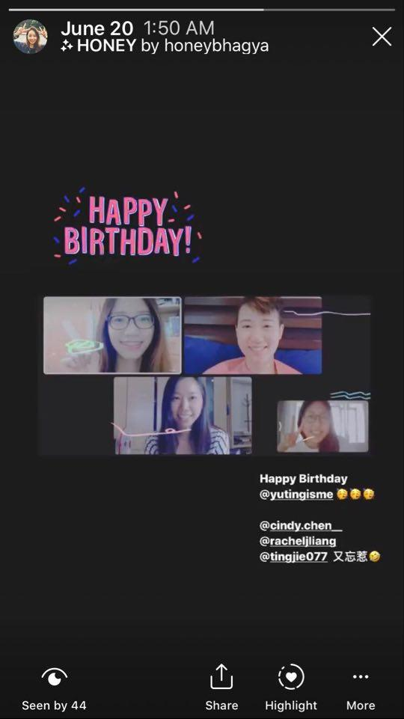

* Rate the movie

**Features might look like:**

* Facebook
  + Comment
  + Personal profile
  + Watch parties
* imdb
  + score(1-10)
  + User reviews
  + Intro
    - Cast
    - Video
    - Photo
    - Storyline
* [Netflix party](https://www.netflixparty.com/)
  + Chat while watching netflix at the same time
* Zoom+
  + Multiple
  + conversation
* Kindle highlight function / coursera save note
  + Similar function: <https://www.christine-lu.com/video>
* Slack/Discord
  + Threads for discussion within a show
* Reddit
  + Conspiracy theories
* Meetup/Tinder
  + Meet people with same interests in locality
* Eating App Taiwan <https://www.eatgether.com/>
  + Go movie watching together

**Requirements**

1. Watch content with family remotely and privately
   * Zoom
     + VC
     + Share screen
   * Netflix Party
     + Chat
     + Sync screen
2. Create anticipation by scheduling watch parties and pre-event discussion
   * Facebook
     + Watch Party
3. Engage in real-time conversations before, during, or afterwards
   * Slack
     + Threads
   * Facebook
     + Groups
   * Netflix Party
     + Chats
4. Schedule and join small community and larger worldwide watch parties
   * Google Calendar
     + Scheduling calls/events
   * Facebook
     + Events
5. Make and share lists of favorite content and content creators
   * Youtube
     + Make your own playlist and share
   * Netflix
     + Your own list
6. Share relevant references to the content subject for further interest and education
   * Tag links
   * FAQ
   * Amazon common questions
7. Help connect people with more diverse content, cultures, locales, and subject matter
   * Facebook
   * Reddit
   * % match
   * Genres
8. Encourage ratings and reviews, and share personal favorites with others
   * Youtube
     + Likes/dislikes
     + Comments/reviews
   * Amazon
     + Ratings
     + Reviews
     + FAQ
   * Tinder
     + Favourites
     + Wishlist
9. Highlight and make notes of favorite lines, chapters, and Characters
   * Coursera
     + Savenotes
   * Kindle
     + Highlights
10. Discover content by way of other metadata, i.e. highest rated, release date, filming location, running time, writer, subplot, production company, etc
    * Amazon/flipkart
      + Filter by
    * ImDb
      + Lists

**Questions**

* What do I want to watch?
  + Find movies/TV Shows by names
  + Find by Genre, by name, by filtering by rating, actor, writer, location, recommendation etc
* What do I see on clicking TV show/Movie
  + Info like on Netflix
  + Groups/channel related to it
  + Friends who watched/reviewed it
  + Release date, filming location, running time, writer, subplot, production company
  + Fun facts
* What do I do when I am watching?
  + Add people to watch with
    - Chat with people
    - Videocall them
  + Highlight good dialogues/scenes/episode
  + Share on feed/status/other social media
  + Leave comment
  + Give rating (after)
  + Memories section of profile - public/private
* Who do I want to watch it with?
  + Find new people
    - Search people with similar taste (% matching system)
    - Similar interests
  + Existing friends
  + People who are members of existing groups
  + Algorithm decided
* What do I see when I click on a person’s profile?
  + Basic info
  + Image
  + Currently watching/Last watched
  + Wishlist
  + Members of which groups
  + Saved quotes from TV series watched/favourite episodes/ characters
  + %Match with you
  + Favourites list of content and content creators
  + Recent Activities/memories
* What do I want to discuss?
  + Find groups and check group activities
  + Before:
    - Conspiracy Theories/predictions
    - Watch parties
  + After:
    - Unpacking content
    - Meaning/significance/symbolism
    - Predictions for future episode or movie
    - Discussing favorite moments in the show
* What do I want to share?
  + What I am currently watching
  + Who I am watching with
  + Screenshot of watching
  + Video of watching
  + Future/what will I be watching
    - Option to join
  + Personal calendar schedule for the month etc.
* With whom do I share?
  + Individual friends
  + With my followers
  + Group members
* Whom do I meet?
  + List of people in same area
  + People listed by decreasing order of % match of preference
  + Can have right swipe/left swipe functionality
  + Strangers with niche interests
    - Be able to find people who watch “hidden-gem” contents

Zoom Call 1.0

Need for emojis/reactions

Memorable scenes screenshot

Need for netflix party

Match based on interest/percentage

Your calendar

During the movie- call video

Create your own group or make a larger party

Recommended list and preferences list and wi

Automatically transition to video call post the mshlist

**USPs**

1. Matching %
2. Netflix party - Emoji/video call
3. Calendar - Global and individual
4. Channel/thread for discussion

Forum

Tinder matching

Feed/Profile

**Wireframe / prototype pages**

**Total _____ pages (minimum requirement: 15 pages)**

* Home page x1
  + Profile page @daisy
  + Add a party @daisy
  + Movie intro page @tanya
  + Match page @tanya
  + Watching page @aakansha
* Group page
* Search Movie page

**Questions from daisy’s parts when drawing wireframe:**

* Can users watch videos alone? ( views it as “normal nextflix” function )
* Do we have DM functions?
* What’s our brand name XD? ( Personally recommend as easy and closer to NetflixXXX as possible
  + Let’s brainstorm here
    - Netflxer ( daisy )
* Shall we follow Netflix design color/guideline for our UI baby? ( since we dont hav much time, i will suggest we follow it
* Need you help to rename buttons/ functions XD ( now just used the simplest words

**Home page**

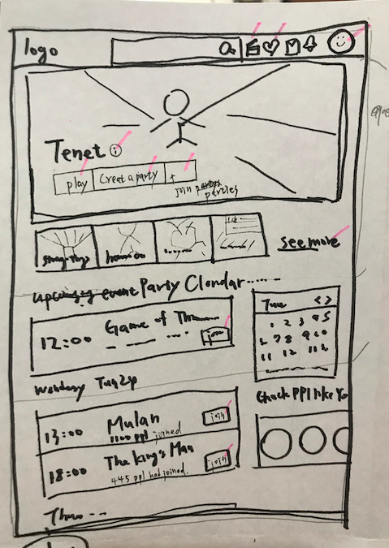

pink strok: click to new pages

Navigation bar(top)

* LOGO
* Search bar
* Profile photo
* Matching %
* DM
* Notification
* Friend’s feed
* Personal Profile photo

Top

* Movies / shows
  + Play / create a party / browse parties

Section 2

* Left side
  + Upcoming events ( related to you)
* Right side
  + Calendar
  + Ppl who match you

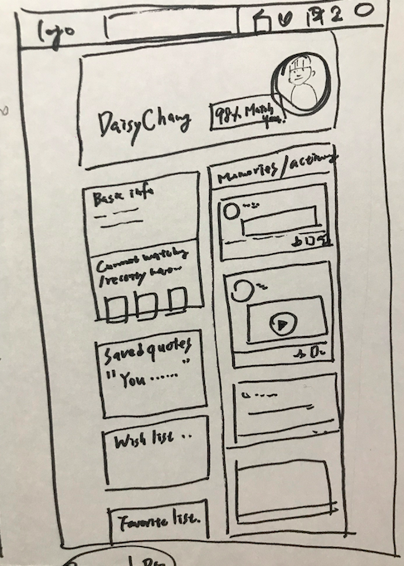

**Profile page**

* + Top
    - Image / name
    - %Match with you
  + Right sidebar
    - Basic info
    - Currently watching/Last watched
    - Wishlist
    - Members of which groups
    - Saved quotes from TV series watched/favourite episodes/ characters
    - Favourites list of content and content creators
  + Left sidebar
    - Recent Activities/memories

**Watching Page**

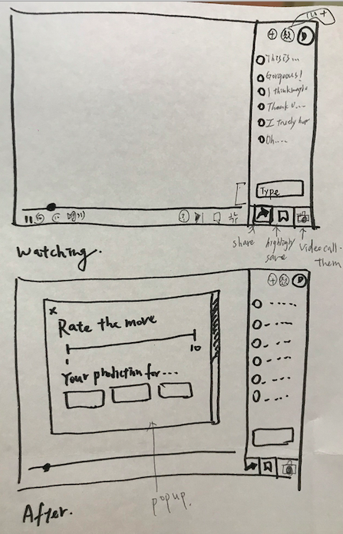

**Watching:**

* Left side
  + Check party members
  + Add new members
  + Chat
  + Type messages
* Left bottom side (3 buttons)
  + Share to social media / memories
  + Save / highlight the lines
  + Video calling with friends

**After:**

* Popup
  + Rate for the movie
  + Predictions for future episode
* Left side
  + Same as watching

**Movie Intro Page**

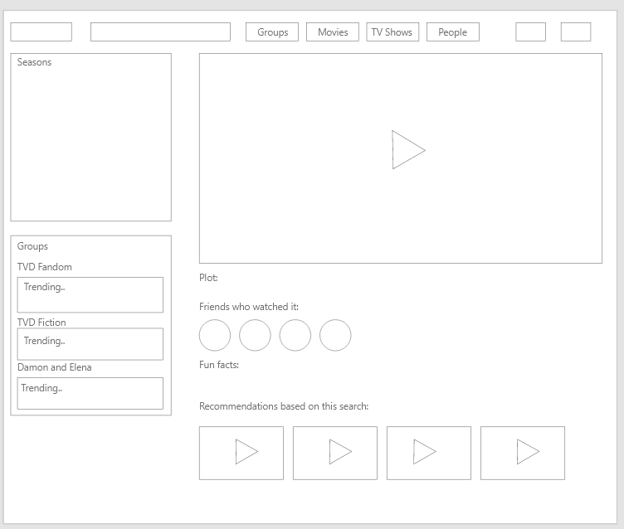

**Add a party**

**Search Movie/TV Show page**

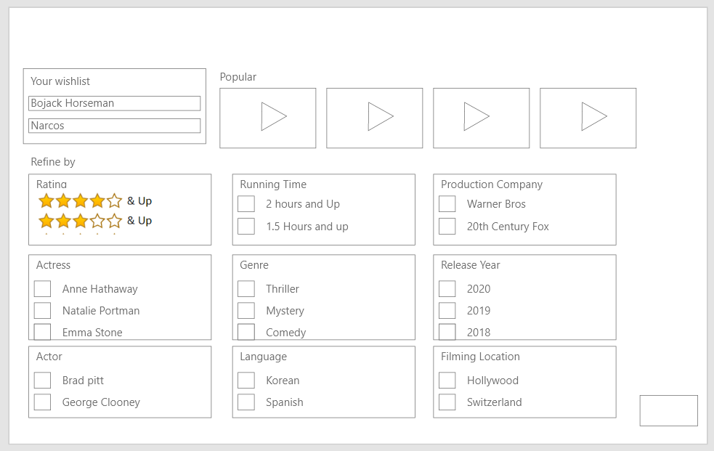

**Group page**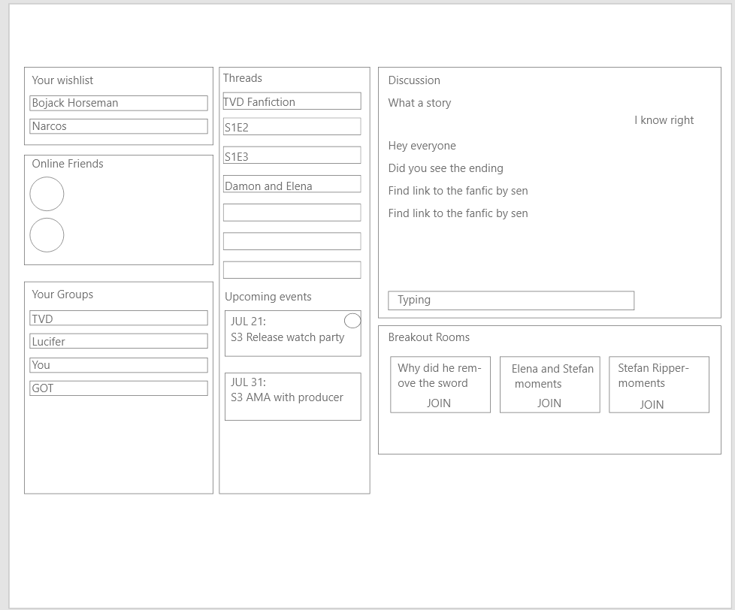

Reference for design

<https://brand.netflix.com/en/assets/>

<https://developer.apple.com/design/resources/>

<https://www.behance.net/gallery/55462459/Wires-wireframe-kits-for-Adobe-XD>